**How Affiliate Customization works**

There are 3 users :

Test 1 : **The seller**

Test 3 : **The affiliate User**

Testaff : **the employer**

Test 1 has this service :

**Write an article about AI Chat GPT**

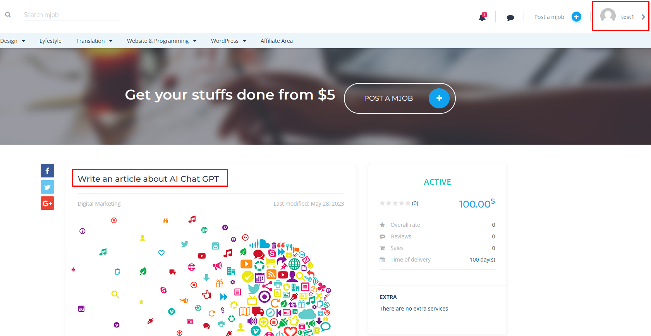

Test 3 know that service and he will go to that mjob link and copy that link :

<https://test.hieubinh.com/mjob_post/write-an-article-about-ai-chat-gpt/>

Now he goes to Affiliate area > paste it into page url and generate refferral URL :

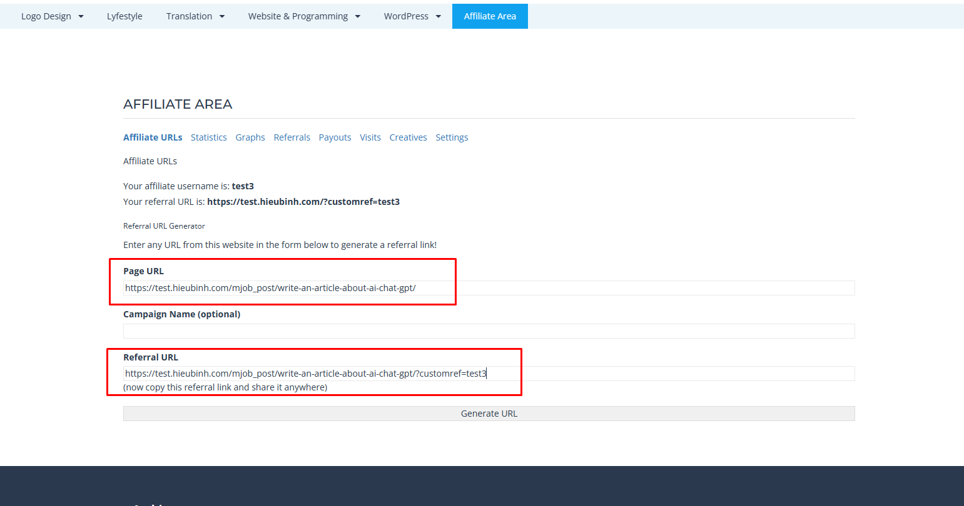

Now He will post that link on his web site or post on facebook , etc, or any platform….

**The employer Testaff** see that link and order that service.

If the order is successful , Test 3 (**The affiliate User )** will get commission

I want to notify you :

1. You should set the same currency for Affiliate plugin with MicrojobEngine.
2. The commission is not relate the commision of MicrojobEngine
3. The commission is calculated by the price of mjob service.

For example : you set commission for Affiliate 10% like this :

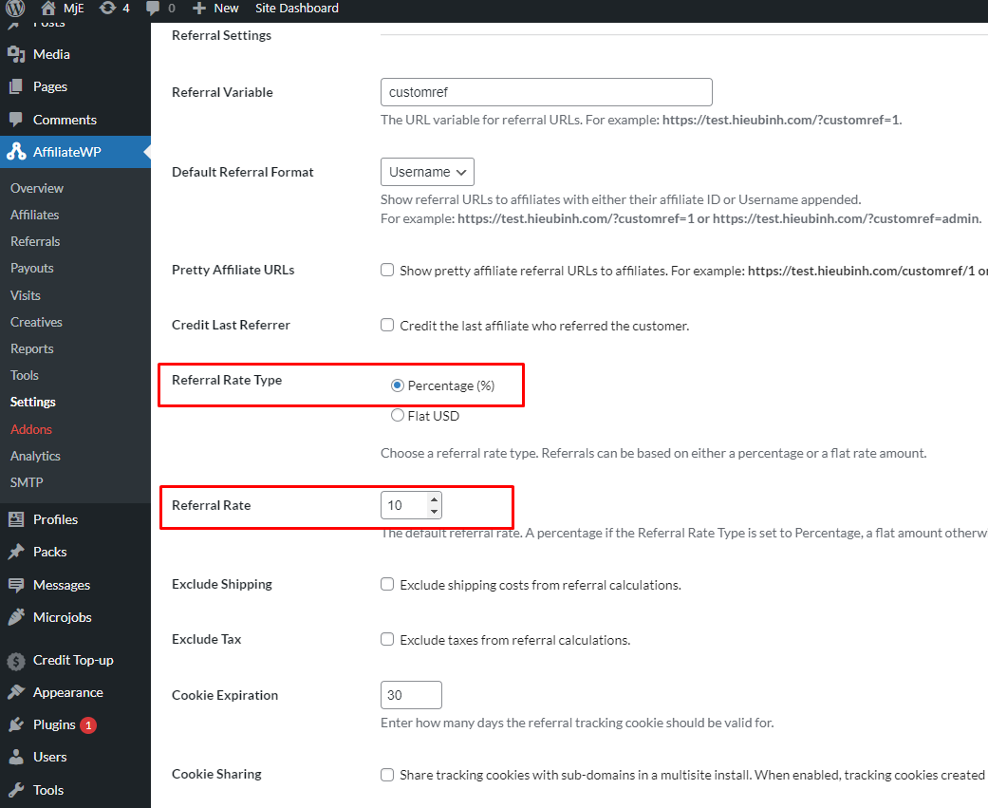

The price of mjob service is 100$

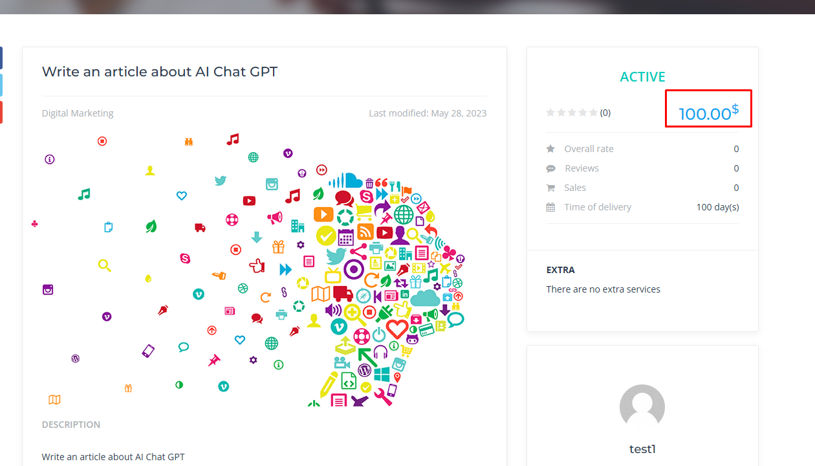

The affiliate user will get 10$ :

